
BRAUNSTONE TOWN COUNCIL
Serving the communities of Braunstone Town and Thorpe Astley
Darren Tilley – Chief Executive & Town Clerk
Braunstone Civic Centre, Kingsway, Braunstone Town, Leicester, LE3 2PP
Telephone: 0116 2890045 Fax: 0116 2824785
Email: enquiries@braunstonetowncouncil.org.uk
www.braunstonetowncouncil.org.uk

TENDERS INVITED
FOR WORKS ON THE CULVERT AND VEHICULAR BRIDGE OVER LUBBESTHORPE BROOK, WORKS TO CAR PARK AND INSTALLATION OF DRAINAGE AT MOSSDALE MEADOWS,
Lubbesthorpe Bridle Road, Braunstone Town, Leicester, LE3 3AH
TENDERS ARE INVITED from suitably experienced Contractors for works on the Culvert and vehicular bridge over Lubbesthorpe Brook, along with drainage down Lubbesthorpe Bridle Path and drainage and refurbishment of car park at Mossdale Meadows.

The work involves:

- To remove existing vehicular culvert bridge over brook
- To replace vehicular culvert bridge with single box culvert as shown at Appendix 1
- To ensure new vehicular culvert bridge surface is sufficient to carry weight of the tractor (maximum net payload 6200kg and 209 cm width) and is sufficient to serve as both pedestrian and vehicular access point
- Raise stone turning area as per the attached plan shown at Appendix 1
- Undertake works to the brook banks as shown in Appendix 2
- To prepare and submit relevant Permit application required for the works, to the Environment Agency
- Drainage work to the entrance of Mossdale Meadows car park to drain water from the car park into the brook as the car park entrance was prone to frequent flooding that was raised during the Walking & Cycling route construction as shown on Appendix 3 and 4.
- Resurfacing of Mossdale Meadows car park with tarmac and repair of broken kerbstones. Currently the car park consists of hardcore and stone which frequently gets washed down towards the brook in heavy rain.
- Inclusion of drainage channels down the Lubbesthorpe bridle path adjacent to the pavilion building to alleviate flooding issues in the workshop as shown at Appendix 5
- Suitable fencing to be installed between car park kerb edge and brook

The Contractor must provide within the quoted price:

- All costs associated with preparing the quote, including site visits;
- Meeting Health &Safety requirements;
- Site Set-up and returning the site to use, including removing all debris from site;
- Carriage and Off-Loading;
- All processing and administration costs;
- All labour and third-party costs; and
- Details of all taxes, including VAT.
- All costs associated with obtaining relevant Permit from the Environment Agency for work to the Culvert Bridge.

The following is available to assist contractors tendering:
- Details of Braunstone Town Council and the open space
- Plans for the required work to the vehicular bridge, car park and drainage
- Photographs of flooding, existing banks and vehicular bridges for reference

Documents are available on Braunstone Town Council’s website www.braunstonetowncouncil.org.uk or by contacting the Deputy Chief Executive & Community Services Manager.

Site visits can be arranged by contacting Pauline Snow on 0116 2899270 or pauline.snow@braunstonetowncouncil.org.uk.

Valid tenders must include details of 1 – 10 above along with the tender price and must be delivered enclosed in a plain, sealed envelope, endorsed “Tender – Works to Mossdale Meadows Flooding” and addressed to the Office of Chief Executive & Town Clerk, Braunstone Town Council, Braunstone Civic Centre, Kingsway, Braunstone Town, Leicester, LE3 2PP, or emailed to executiveofficer@braunstonetowncouncil.org.uk no later than 4pm on Monday 12th August 2024

Note: Canvassing of Members or of any committee, directly or indirectly, for any Contract with the Council shall disqualify the Contractor for such appointment. If an applicant for any appointment or Contract with the Council is to his/her knowledge related to any Member of, or the holder of any office under the Council, he/she and the person to whom he/she is related shall disclose the relationship in writing to the Chief Executive & Town Clerk. A Contractor who fails to do so shall be disqualified for such Contract, and, if appointed, may be dismissed without notice.

Signed:
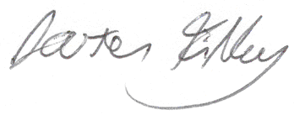
Darren Tilley, Chief Executive & Town Clerk Dated: 21st June 2024

TIMESCALES AND ASSESSMENT

DEADLINE FOR TENDER SUBMISSION: 4pm on Monday 12th August 2024

TENDERS WILL BE ASSESSED AGAINST THE FOLLOWING MATRIX:
- Cost
- Compatibility with Proposals
- Environment
- Methodology

Location

Braunstone is the largest civil parish within the district of Blaby in Leicestershire and one of the largest parishes in England (494 hectares). The population recorded in the 2011 Census is 16,850 (8,371 Males and 8,479 Females). In 2019, the electorate was 12,555. In 2020, there are 7,112 households.

Braunstone Town is suburban and to the north shares a common boundary with the City of Leicester and immediately inside the city boundary is the Braunstone Park estate. To the west of the parish lies the M1 motorway with junction 21 at the south western tip. To the south lies Fosse Shopping Park and Grove Triangle retail parks.

The western part of the parish adjacent to the M1 and west of the Leicester outer ring road contains the Meridian Business and Leisure Parks and a modern housing development, Thorpe Astley.

The Council

Braunstone Town Council comprises of 21 Councillors who are elected every four years. Each year the Council elects from amongst its number the Town Mayor, Deputy Town Mayor, Leader of the Council and Deputy Leader of the Council.

The Town Council provides a wide range of services to the citizens of Braunstone Town together with social and recreational facilities. The Council also promotes the interests of the town in its representation to other bodies. It works in partnership with the larger District Council and County Council to provide and supplement local government services within the town area. The focus of our work is summed up in our Mission Statement:

We exist to ensure that local services and the environment reach the highest possible standards, within the resources available, for citizens, visitors and those who work in Braunstone Town:
- to provide a focus for civic pride;
- to listen, identify and respond to agreed local needs; and
- to help develop a strong, secure, self-reliant, self-confident community, free from unlawful discrimination.
"Spectemur. Agendo" translates "Let us be Judged by Our Actions"

The Council was granted Quality Status in February 2004, re-accredited in January 2009 and was awarded Foundation status under the Local Council Awards Scheme in January 2014.

Our Open Spaces & Parks

The Town Council is responsible for maintaining the Town’s open spaces and parks, the objectives of the Town Council in this respect is:
- to provide and maintain parks and open spaces to a high standard;
- to provide quality sports facilities to meet identified needs;
- to provide and maintain play equipment to a high and safe standard; and
- to help fight pollution by planting trees on our parks.
We are responsible for nearly 32 hectares of land, which includes sports pitches, playgrounds, nature areas, woodland, an orchard and meadow.

For the nature lovers, a small brook runs through the park, and there are a huge amount of wooded areas and natural areas around the park. A woodland walk eventually connects to the Osiers nature reserve.

Mossdale Meadows also connects to Merrileys Park, a natural woodland and wildlife area. In total, the park is 9.51 hectares / 23.5 acres in total.
To reach the park by car, your best option will be the Kingsway entrance, which has a small car park.
Mossdale Meadows

Mossdale Meadows is one of the Town Council’s larger parks, and hosts our yearly Summer Fete. It is quite a varied park, with a good range of sports equipment and pitches, as well as plenty of natural areas.
The main entrance is off the Kingsway itself, with a decent sized car park available. Next to the car park there is a children’s play area, and a multi-use games area including a skateboard area and a basketball court.
Further into the park, there is a changing room and numerous football pitches.
Mossdale Meadows Flooding and Brook Photo Gallery

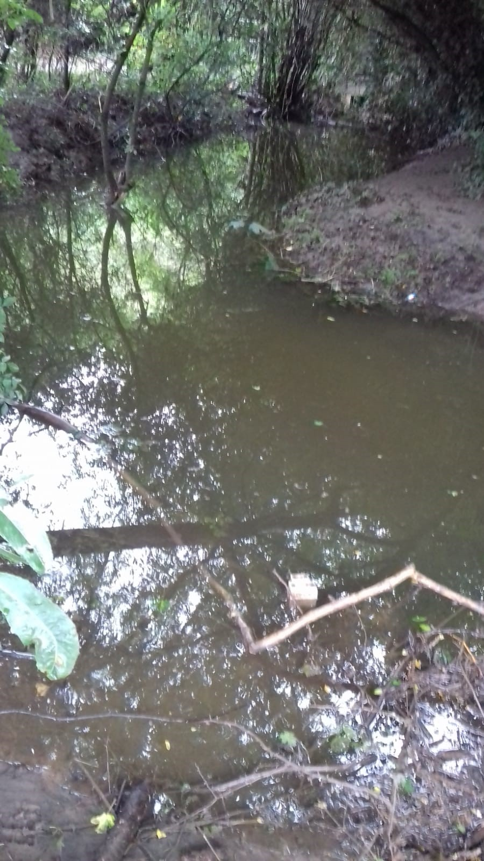

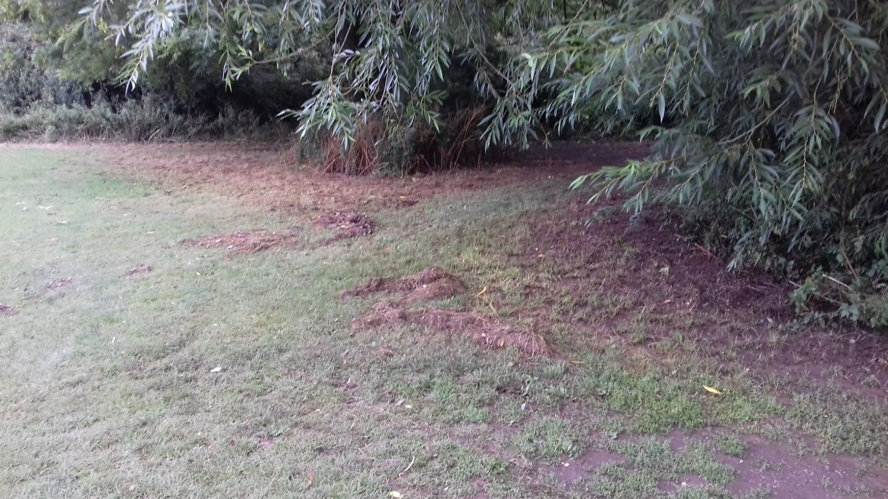

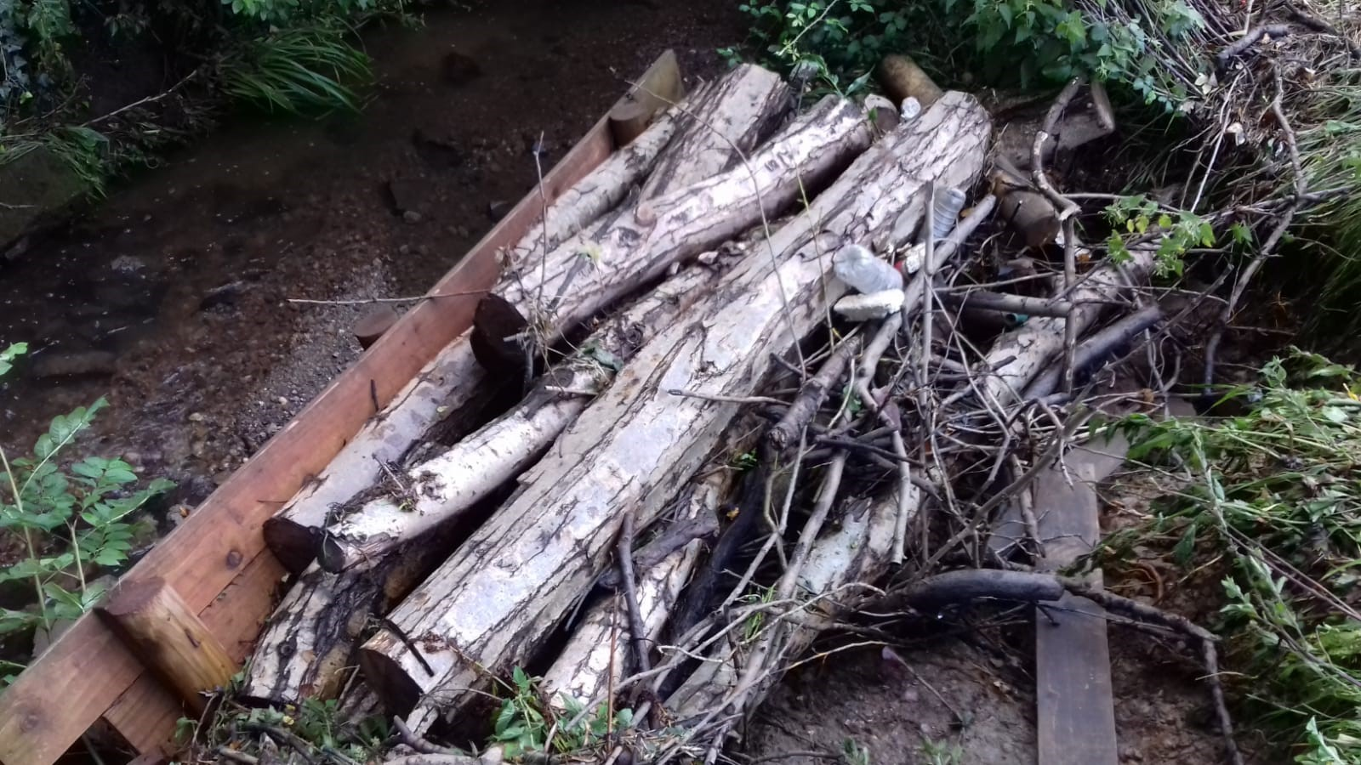
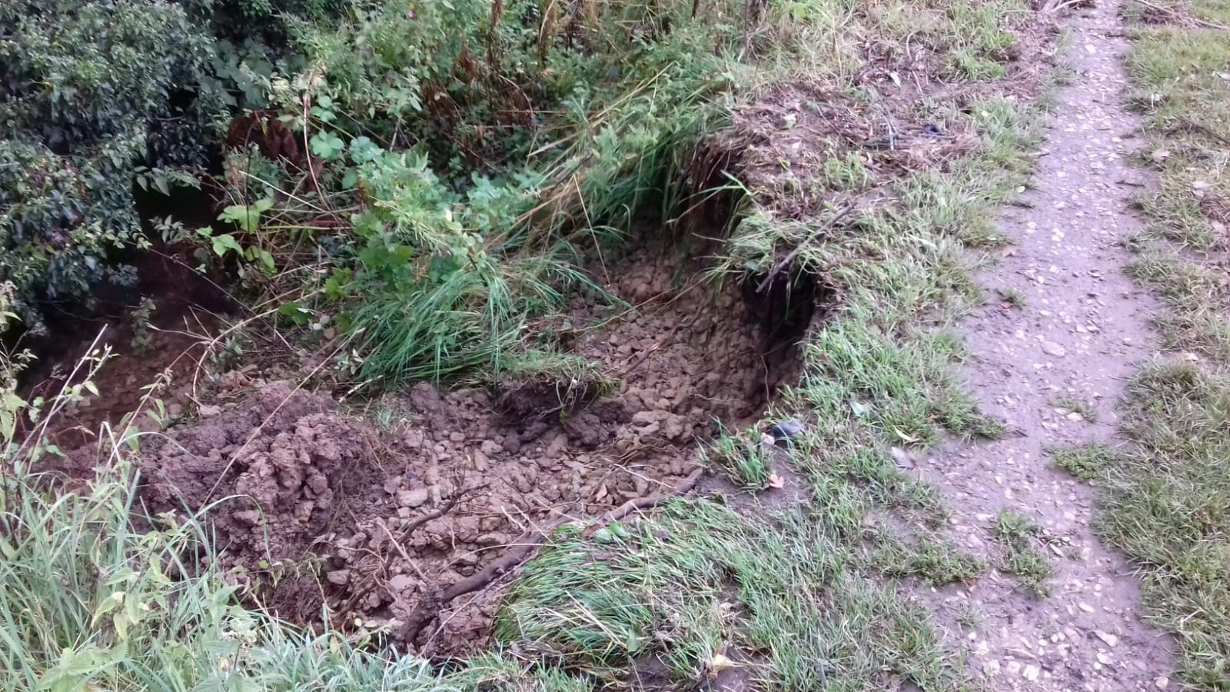

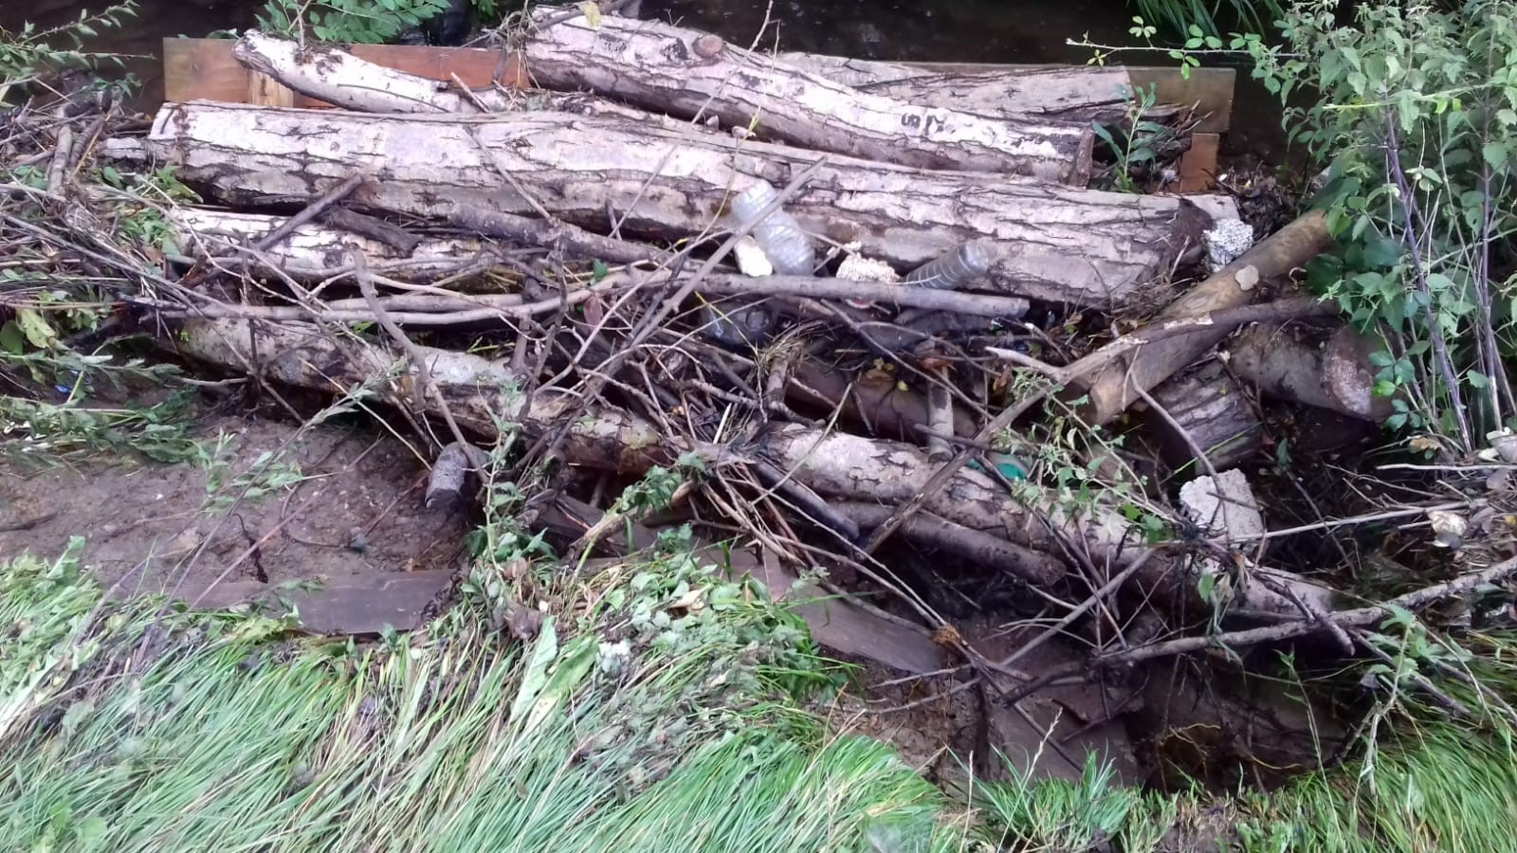

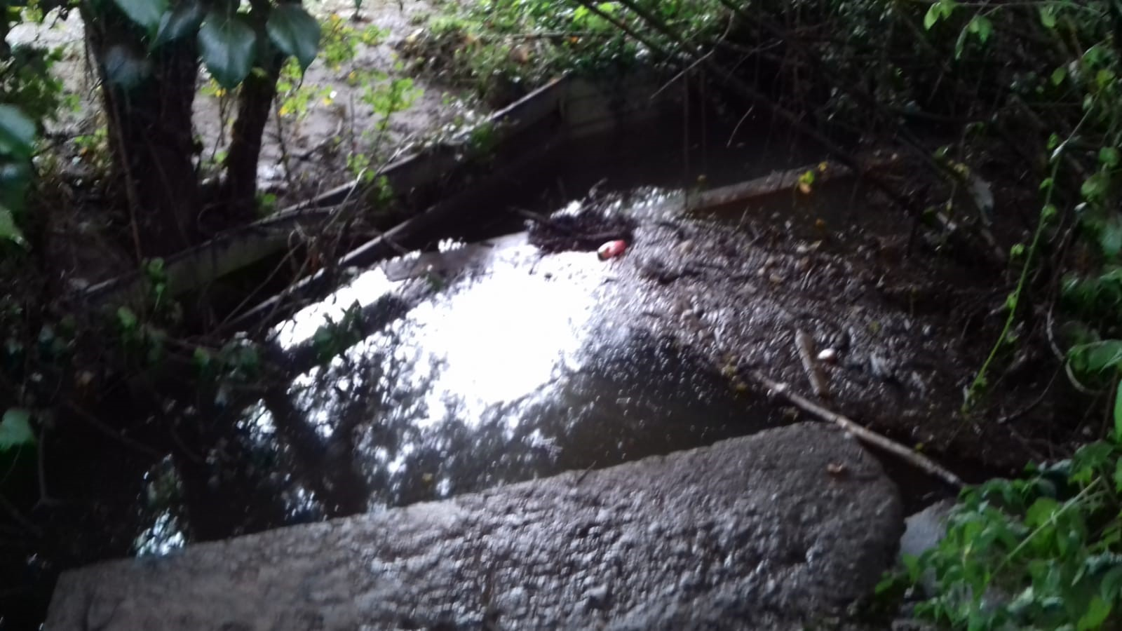

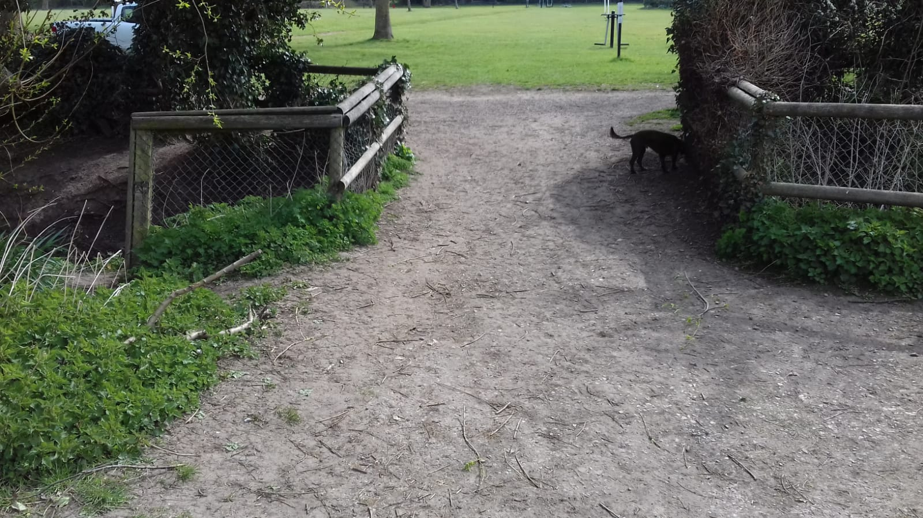

Vehicular Bridge

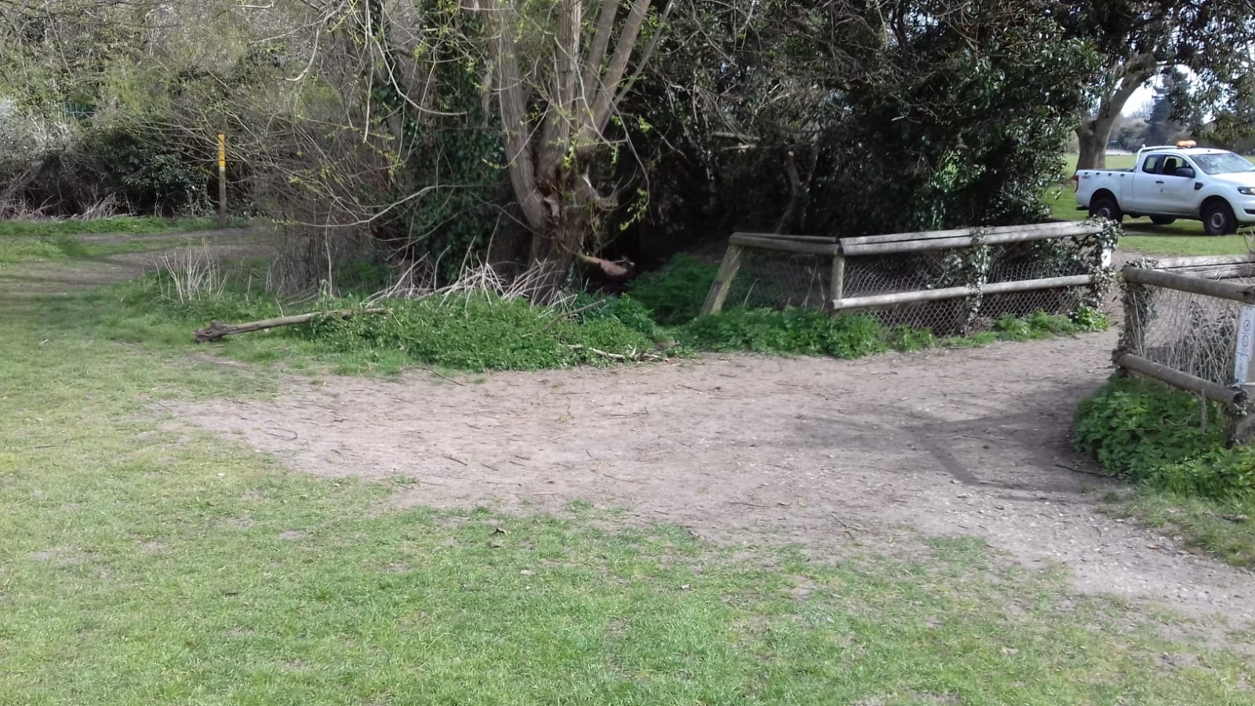

Vehicular Bridge

